Level 5 -> Level 6

The goal of this level is to find the pass to log into <http://natas.6natas.labs.overthewire.org>.

Username: natas6

After logging into level 5 we got a message that **“Access disallowed. You are not logged in**”.

Again, we need to intercept the request for natas5 using burp suit. The snapshot below shows the intercepted request.

The problem is with the Cookie. We accessing page, with the [existing logged in session](https://phppot.com/php/php-login-script-with-session/) with the cookies. But the logged-in flag is set to zero, that is why we are unable to log in.

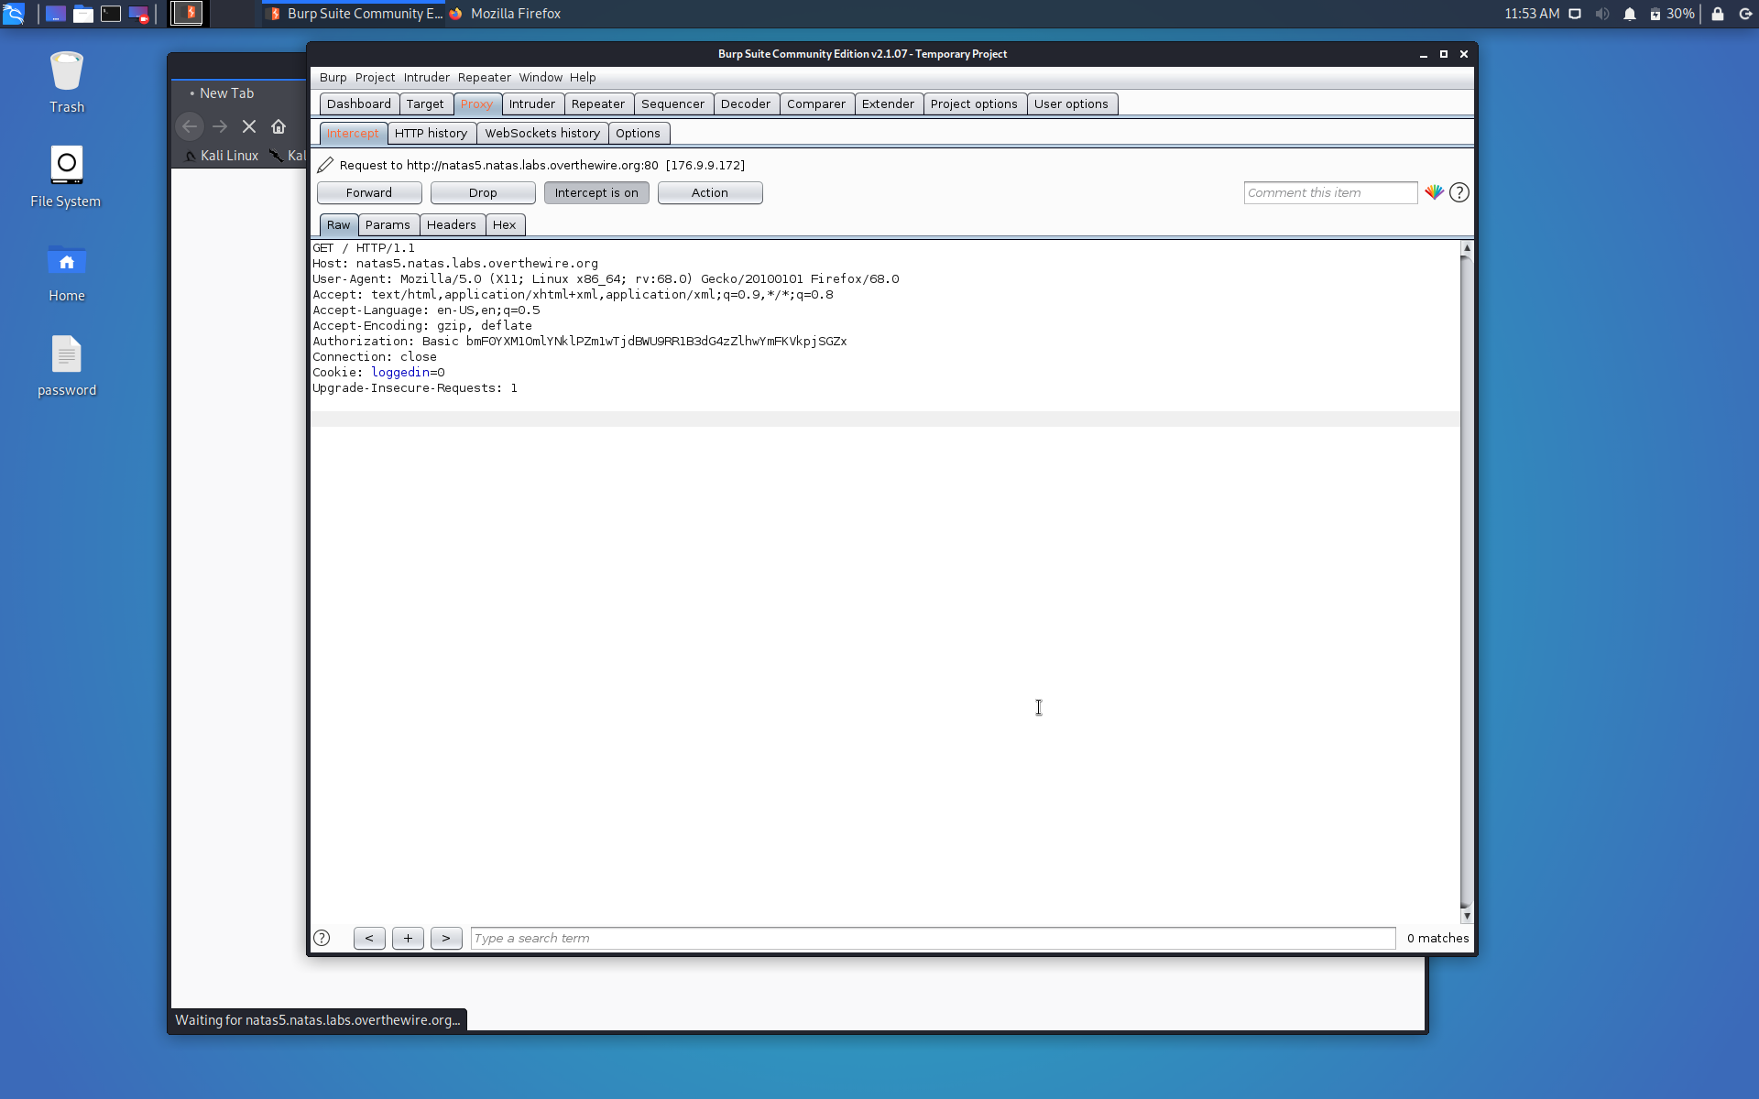

Here, we just need to change the logged-in flag from 0 to 1 and forward the request.

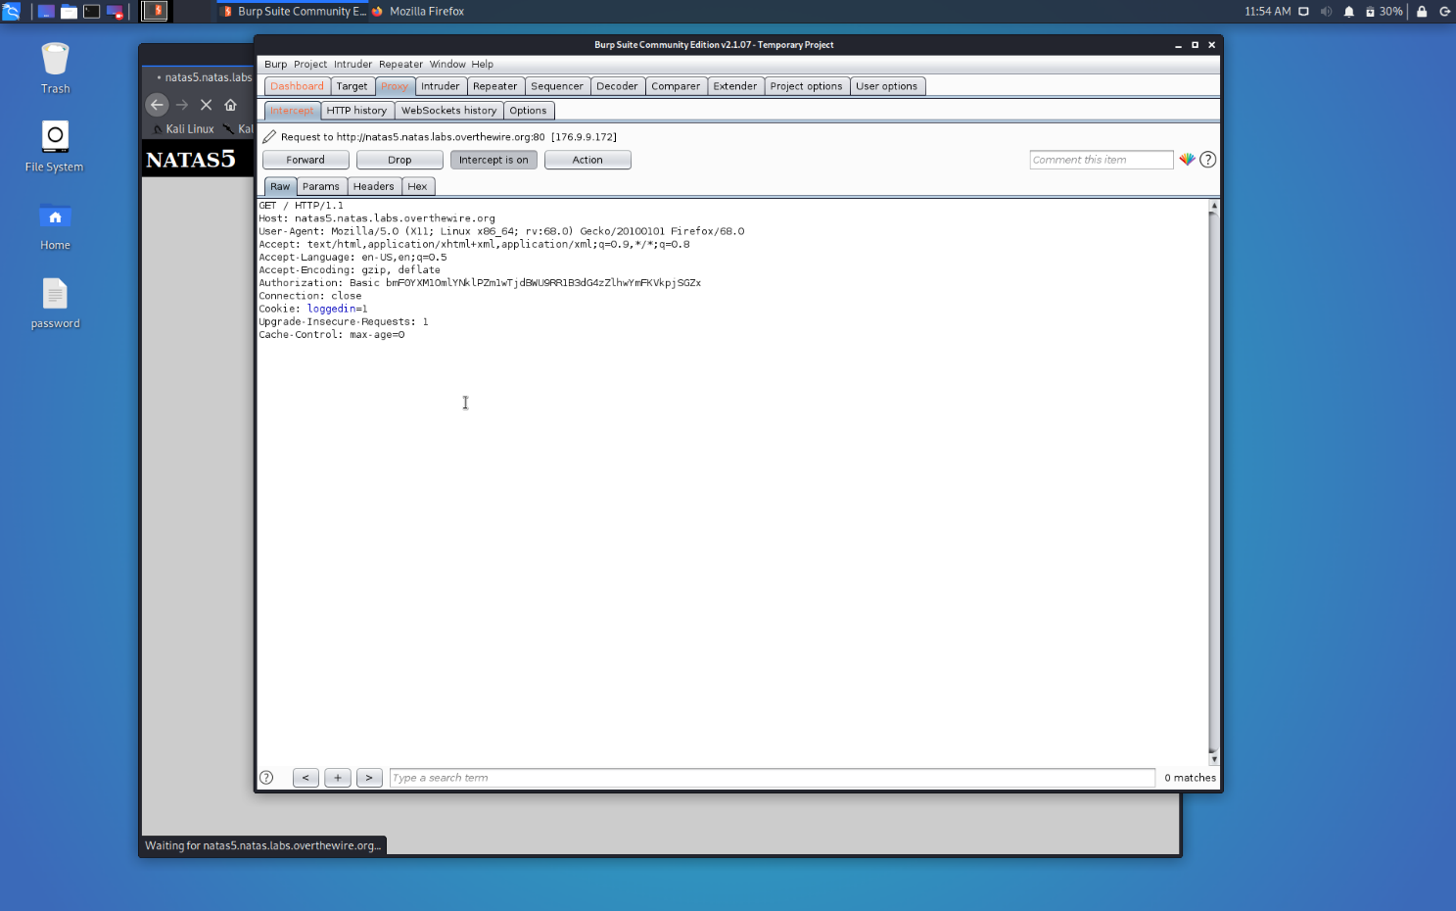

As soon as we will forward the request we are successfully logged in Natas5 and got the password to the next level at it’s home page only.

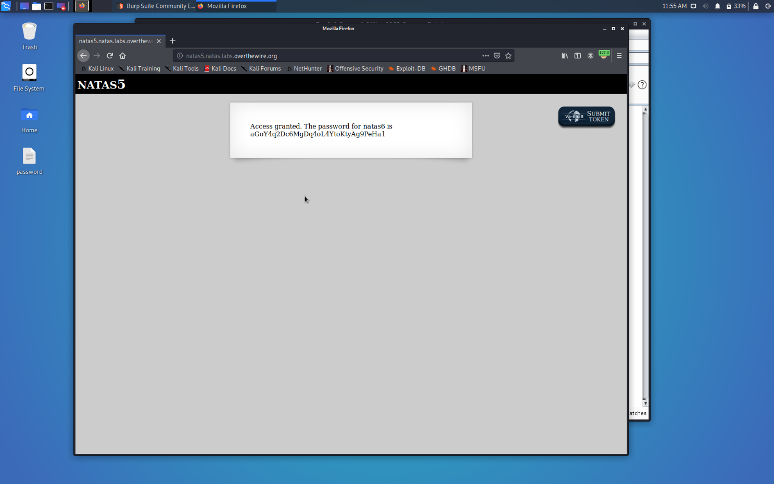

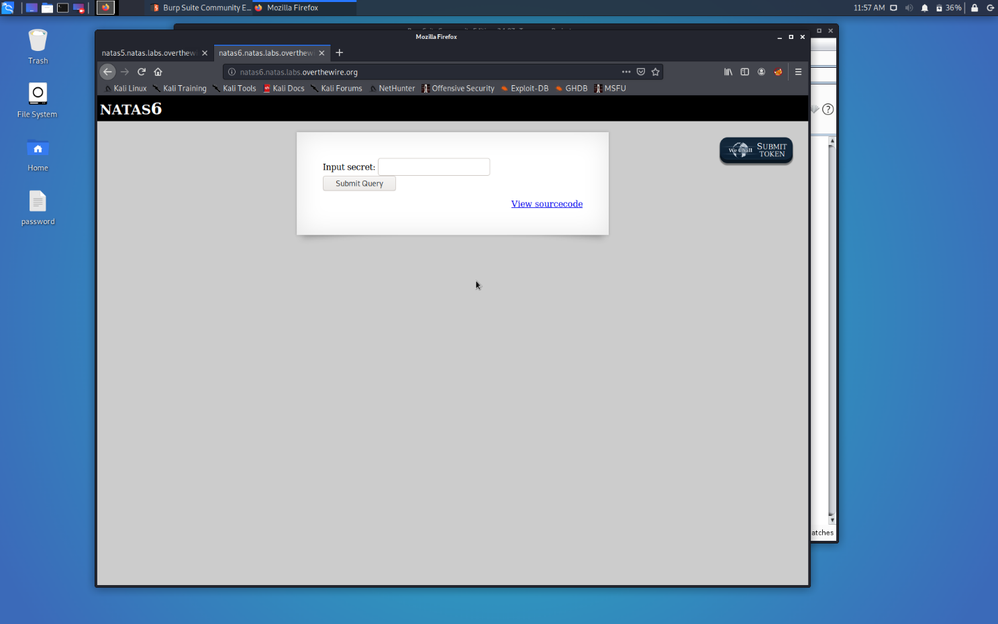

Successfully passed level 6.…